

FORENSIC TOOLS

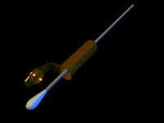

Swab
A cotton-tipped swab used to collect sterile forensic samples of fluids or dried liquids, which will later be processed and analyzed in the CSI lab.

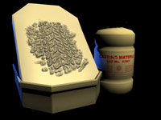

Casting Plaster and Frame
A metal frame that is filled with plaster, used to take impressions of shoe prints, footprints, and tire tracks at a crime scene.

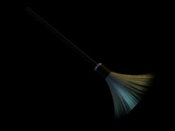

Fingerprint Brush

This brush is used with fingerprints powders to enhance fingerprints on smooth surfaces. Although most fingerprints are identified using black powder, there are many different colors of fingerprint powder (e.g., white, pink, green). The different colors are used to provide contrast on items that would not be visible if black powder were used.

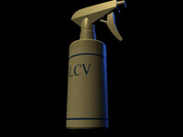

LCV (Leuko Crystal Violet)

Hexamethyl-p-rosaniline chloride, a liquid accelerant that fluoresces when even trace amounts of blood are present. It is used to positively identify small amounts of blood.

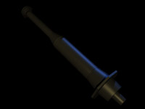

Magnetic Brush

Magnetic brush is used to enhance fingerprints on certain porous objects, such as wood, polystyrene, and painted surfaces. It is used in combination with a magnetic powder for fingerprint analysis on both vertical and horizontal surfaces.
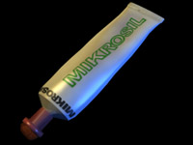

Mikrosil™

A thick, putty-like casting material used to make molds of wounds and tool marks on a variety of surfaces.
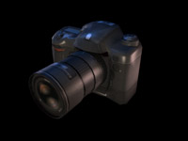

Camera

Visual evidence, such as spatter patterns or graffiti can be gathered by taking pictures with the camera. The camera is also used to document the crime scene, including pictures of the victim’s body position and the body’s relation to the environment when found.
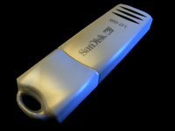

USB Data Drive

A USB device with special decryption software that can be used to detect hidden or encrypted information on a suspect’s computer.
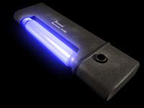

Ultraviolet Light

A handheld device that provides light at various wavelengths to enhance otherwise invisible pieces of evidence, including fluids, bruising, and accelerants.

